**JEWSON WESTERN FOOTBALL LEAGUE DIVISION ONE**

Sturminster Newton United

Vs

Warminster Town FC

Tuesday 17th September 2024

Kick off -19:45pm

This programme has kindly been sponsored by Wessex Photos of Sturminster Newton!

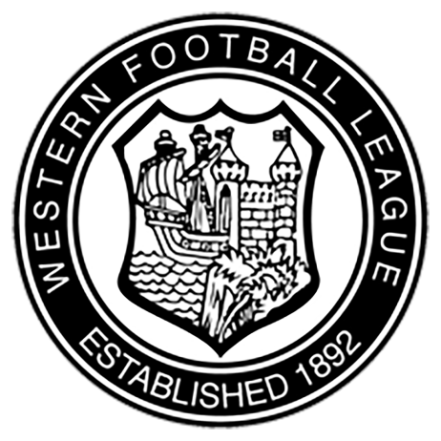

**Welcome to Barnett’s Field**

The Home of Sturminster Newton United FC

Officials At Barnett’s Field

**President:** Richard Frear

**Vice President:** Steve Clarke

**Chairman:** Lee Bright

**Vice Chairman:** Ian Myall

**Club Secretary:** Justine Turnball

**Football Secretary:** Phil Blakey

**Treasurer:**  John Cowley

**Welfare Officer:** Adam Kellaway

**Director of Football:** Dan Carroll

**Director of Operations:** Mark Deakin

**Social Media:** Sophie Cowley

**Social Media:**  Ellie Cowley

**Committee Members:** Debbie Bright

Jordan Edmonds

Fred Douch

Andy Green

Mark Rowland

**Social Media:**

As of the 2023/24 season we looked to increase our coverage heavily on social media. With this in mind, we were on the look out for a couple of individuals around the club who would be willing to give up some of their time to help create designs for our Website, Instagram, Facebook and Twitter. Without hesitation stepped forward, Sophie and Ellie Cowley. It goes without saying that they have contributed immense amount of time to produce some amazing designs for our social media and help design the new website. As a club, we cannot thank you both enough for the time and effort you have both put in. Thank you!

You can catch all our updates on our socials here:

[www.snufc.com](http://www.snufc.com)

<https://www.instagram.com/sturminsternewtonutdfc/>

<https://www.facebook.com/snufcfp>

<https://x.com/SturNewUtdFC>

**Away vs Mendip Broadwalk Match Report**

**Photos Courtesy of Connor Stanfield**

Saturday sore us travel to Mendip Broadwalk for a newly promoted derby. Both teams competing well and at 2 places apart in the middle of the table meant there was a lot on the line.

An early injury to Ash Clarke meant that young lad Harry Smith came on in hope to replace Ash for the remaining 75 Minutes. 1st Half ended 1-1 with our CB Billy Bright on the scoresheet for both goals.

2nd half started much better with the cherries controlling most of the game from here. Attacking up the hill visible wore off on the opponents allowing us to take a bit more time in our decisions. Elliot Bevis coming on and managing to pick himself up a nicely finished goal and Harry Smith with a lovely “strikers” goal after a mix up between the oppositions goalkeeper and centre half sealed the win.

**Man of the Match VS Mendip Broadwalk**

**Neil Sweatman Sponsored by Complete Boiler Care**

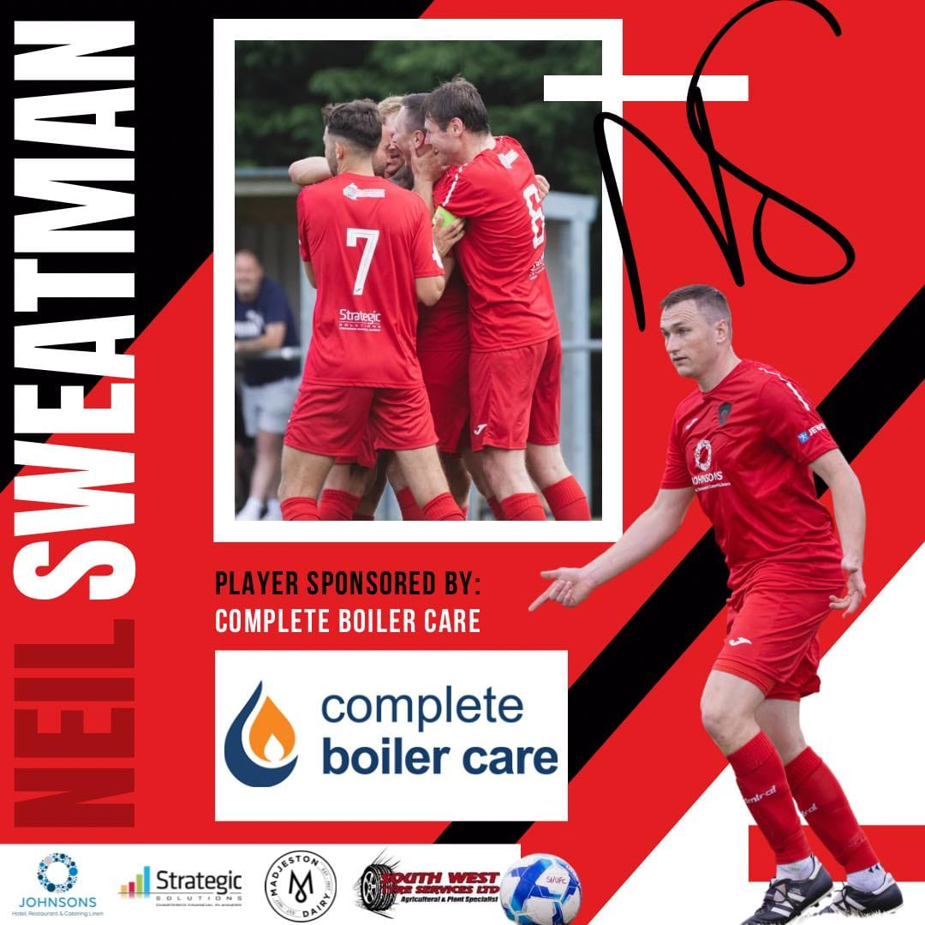

**Sturminster Newton United FC – History**

In 1874 the club, which was then known as the Panthers FC, became the first ever club from the West Country to participate in the FA Cup, reaching the second round on three occasions.

In 1877-78 they played the legendary Wanderers in the first round but lost 9-1. In the 1890’s their name was changed to Sturminster St Mary’s, with the current name adopted in 1945.

They were among the founding members of the Dorset Combination in 1957, having previously played in the Dorset League. After leaving the league due to financial difficulties in 1960, they played in the lower Dorset Senior League until they re-joined the Combination in 1972. They remained in that competition (since 2002 known as the Dorset Premier League) until 2011, when they were relegated to the Dorset Senior League. During this time, they won the Combination Cup twice, in 1981 and 1995.

They moved from a public recreation ground to their own stadium in Honeymead Lane in 1996.

In 2011-12 under Gary Head, in his first full season in charge, the club won the Dorset Senior Trophy with a 1-0 win over Parley Sports at Wimborne Town. In 2021-22 under the management of Nick Squires the club won its second Dorset Senior Trophy, beating Merley Cobham Sports 2-1 at The County Ground, Hamworthy. In 2022-23 the club continued their success adding the Dorset Premier League Cup to the trophy cabinet beating Sturminster Marshall 4-1 at Wimborne Town. The 2023-24 season has been the most successful in the clubs history as they have won the Dorset Premier League for the first time and have gained promotion to Step 6.

**Dorset League Division One Winners 1971-72**

**Dorset Senior Trophy Winners – 2011-12 and 2021-22**

**Dorset Combination League Cup Winners – 1980-81 and 1995-96**

**Dorset Premier League Cup Winners – 2022-23 and 2023-24**

**Dorset Premier League Winners 2023-24**

**League Table**

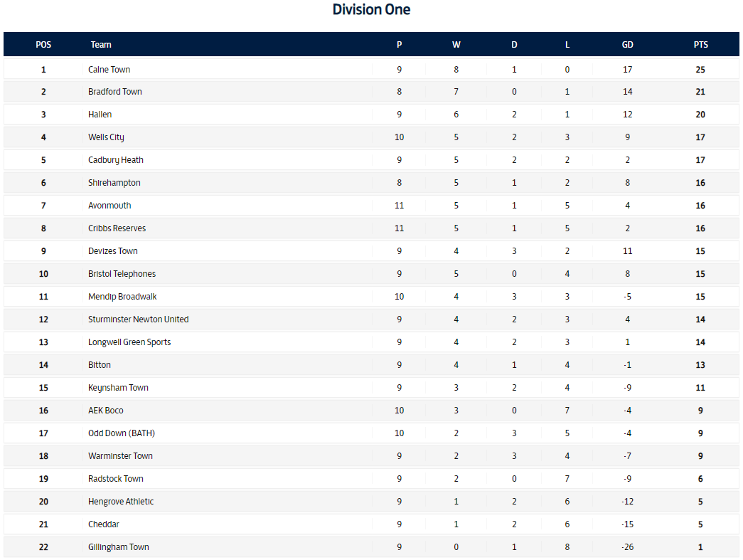

**Silent Disco 28th September!**

**Squads**

**Match Officials:**

Referee: Mark Burrough

Assistant 1: Mark Chinnock

Assistant 2: Johnathan Marsh

**Thank You to our Headline Sponsors**

**This Fixture is Kindly Sponsored by**



Darren trained as cabinet maker (Litton Furniture) when he left school at 16. Once he completed his course he progressed his career into carpentry. This enabled Darren to take on new challenges and become self-employed.

Following 2 years mainly working on projects on behalf of 2 local businesses some of which evolved multi-million-pound developments. In 2006 Darren established Darren Moody Carpentry, this was due to huge demand built up from word of mouth.

Over the years Darren has built a strong reputation for being known as a**reliable, fair and honest carpenter** this has all been achieved by providing**a very high standard of work**.

Be sure to get in touch with Darren on 07854 663847